*ProtoControl*

System Architecture Diagrams

Team Members:

[Kelly Mae Allen](mailto:kmallen5@ncsu.edu)

[Nida Kosedagi](mailto:nkoseda@ncsu.edu)

[William Wood](mailto:whwood@ncsu.edu)

[Parker Sexton](mailto:pbsexton@ncsu.edu)

[Abisha Fenn](mailto:arfenn@ncsu.edu)

Sponsoring Entity:

Parker Sexton

Date: 9/19/23

# 

# 

Table of Contents

**1. Project Background 2**

Key Product Requirements: 2

Key features: 2

Key constraints: 3

**2. Product Concept Diagrams/Drawings: 4**

2.1a ProtoPad 4

2.1b ProtoPad Key (zoomed in) 5

2.2 ProtoKit 6

2.3 Modular (location dependent) 7

2.4 Modular (component dependent) 8

2.5a Mobile Device as Touch Screen 9

2.5b Mobile Device as Touch Screen (zoomed in) 10

2.6 Software UI 11

Concept differences table and mockup demo preparation: 12

**3. User Pperational Flowchart/Process Diagrams 13**

3.1 Software UI/Touchscreen Iteration **13**

3.2 Physical Components/UI Iteration 14

3.3 ProtoKit Assembled 15

**4. System Functional Block Diagram 16**

4.1 Touchscreen (ProtoPad, Mobile App + Smartphone Display, Software UI) 16

4.2 Physical Component UI (ProtoKit, Component dependent, Location dependent) 16

**5. Table of Trade-offs 18**

**6. Design challenges 20**

**7. First technical milestone Preparation (“Hello World” demos) 21**

**8. Long-lead-time or critical items for purchasing 23**

**A note to the Professors and TAs: This draft of the System Architecture Drawings has been edited past 11:59 Friday 22nd. While we understand that it is late, it is a better reflection of our project and we hope you will consider it. If that is not possible, draft1 (linked on the website) has not been edited past 10:56pm Friday, 22nd.**

# **Project Background**

*Protocontrol simplifies User Interface development for a variety of devices with a quick, intuitive, and visually pleasing solution.*

*Designing and building a user interface takes a significant amount of time, reducing the efficiency of the prototyping process and taking valuable engineers away from the main problem they were tasked with solving. Furthermore, while the systems beneath the User Interface may vary greatly, the process of developing a User Interface is fairly redundant across projects and can be streamlined into a single versatile product.*

*Protocontrol allows engineers and hobbyists to execute their vision for a user interface panel with a start-to-finish user interface development experience. The user will have access to a variety of configurable options when customizing their panel and receive a ready-to-mount panel that plugs into a specified microcontroller. Protocontrol will be designed with particular microcontroller families in mind. Protocontrol is an ideal solution for small microcontroller based systems and Product Engineering teams that can use an interface panel as a testbench. With Protocontrol, we make User Interface ideas into a reality with auto generated code and a modular device to fit any user interfacing needs.*

## **Key Product Requirements:**

### Key features:

The heart of Protocontrol lies in the process of building the user interface, not necessarily the final product. This is achieved in two major categories: Hot swappable hardware, Generation Software, and Compatibility.

1. **Hot swappable hardware:** The central panel has ports that connect to a variety of Input components that can be quickly changed. The enclosure surrounding the panel and components must be ergonomic.
2. **Generation Software:** The Digital user interface can be generated from a simple sketched drawing, allowing users to design the layout of their custom user interface with little to no technical knowledge.
3. **Compatibility:** ProtoControl will be compatible with a huge variety of devices by providing a large selection of input devices and adhering to existing communication protocols to interface with almost every existing microcontroller.

### Key constraints:

1. The panel must easily slot onto or include a standard microcontroller (ie Arduino, Raspberry PI, ESP32, MSP430) .
   1. The panel’s power requirements should be compatible the user’s system or the panel should be able to modulate power inputs as needed
   2. The panel’s shape/size be conducive to attaching to common dev boards
   3. The panel must use industry standard pins and ports
2. The entire process from start to finish must be as straightforward enough to be used by someone with limited electrical and computer engineering knowledge (including students, hobbyists, and engineers from other disciplines)
3. The product should be affordable/competitive with market prices

# **Product Concept Diagrams/Drawings:**

## **2.1a ProtoPad**

## 

## **2.1b ProtoPad Key (zoomed in)**

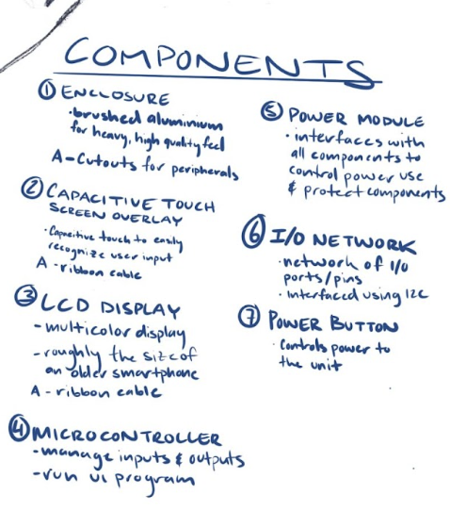

Description: Concept for touch screen device that can have a user interface and controls configured on a companion software than used as a UI for a given system (in this case a light bulb)

## **2.2 ProtoKit**

## 

Description: Concept for a User interface kit that ships with a central panel and a choice of side panels that can be magnetically attached to the panel.

## **2.3 Modular (location dependent)**

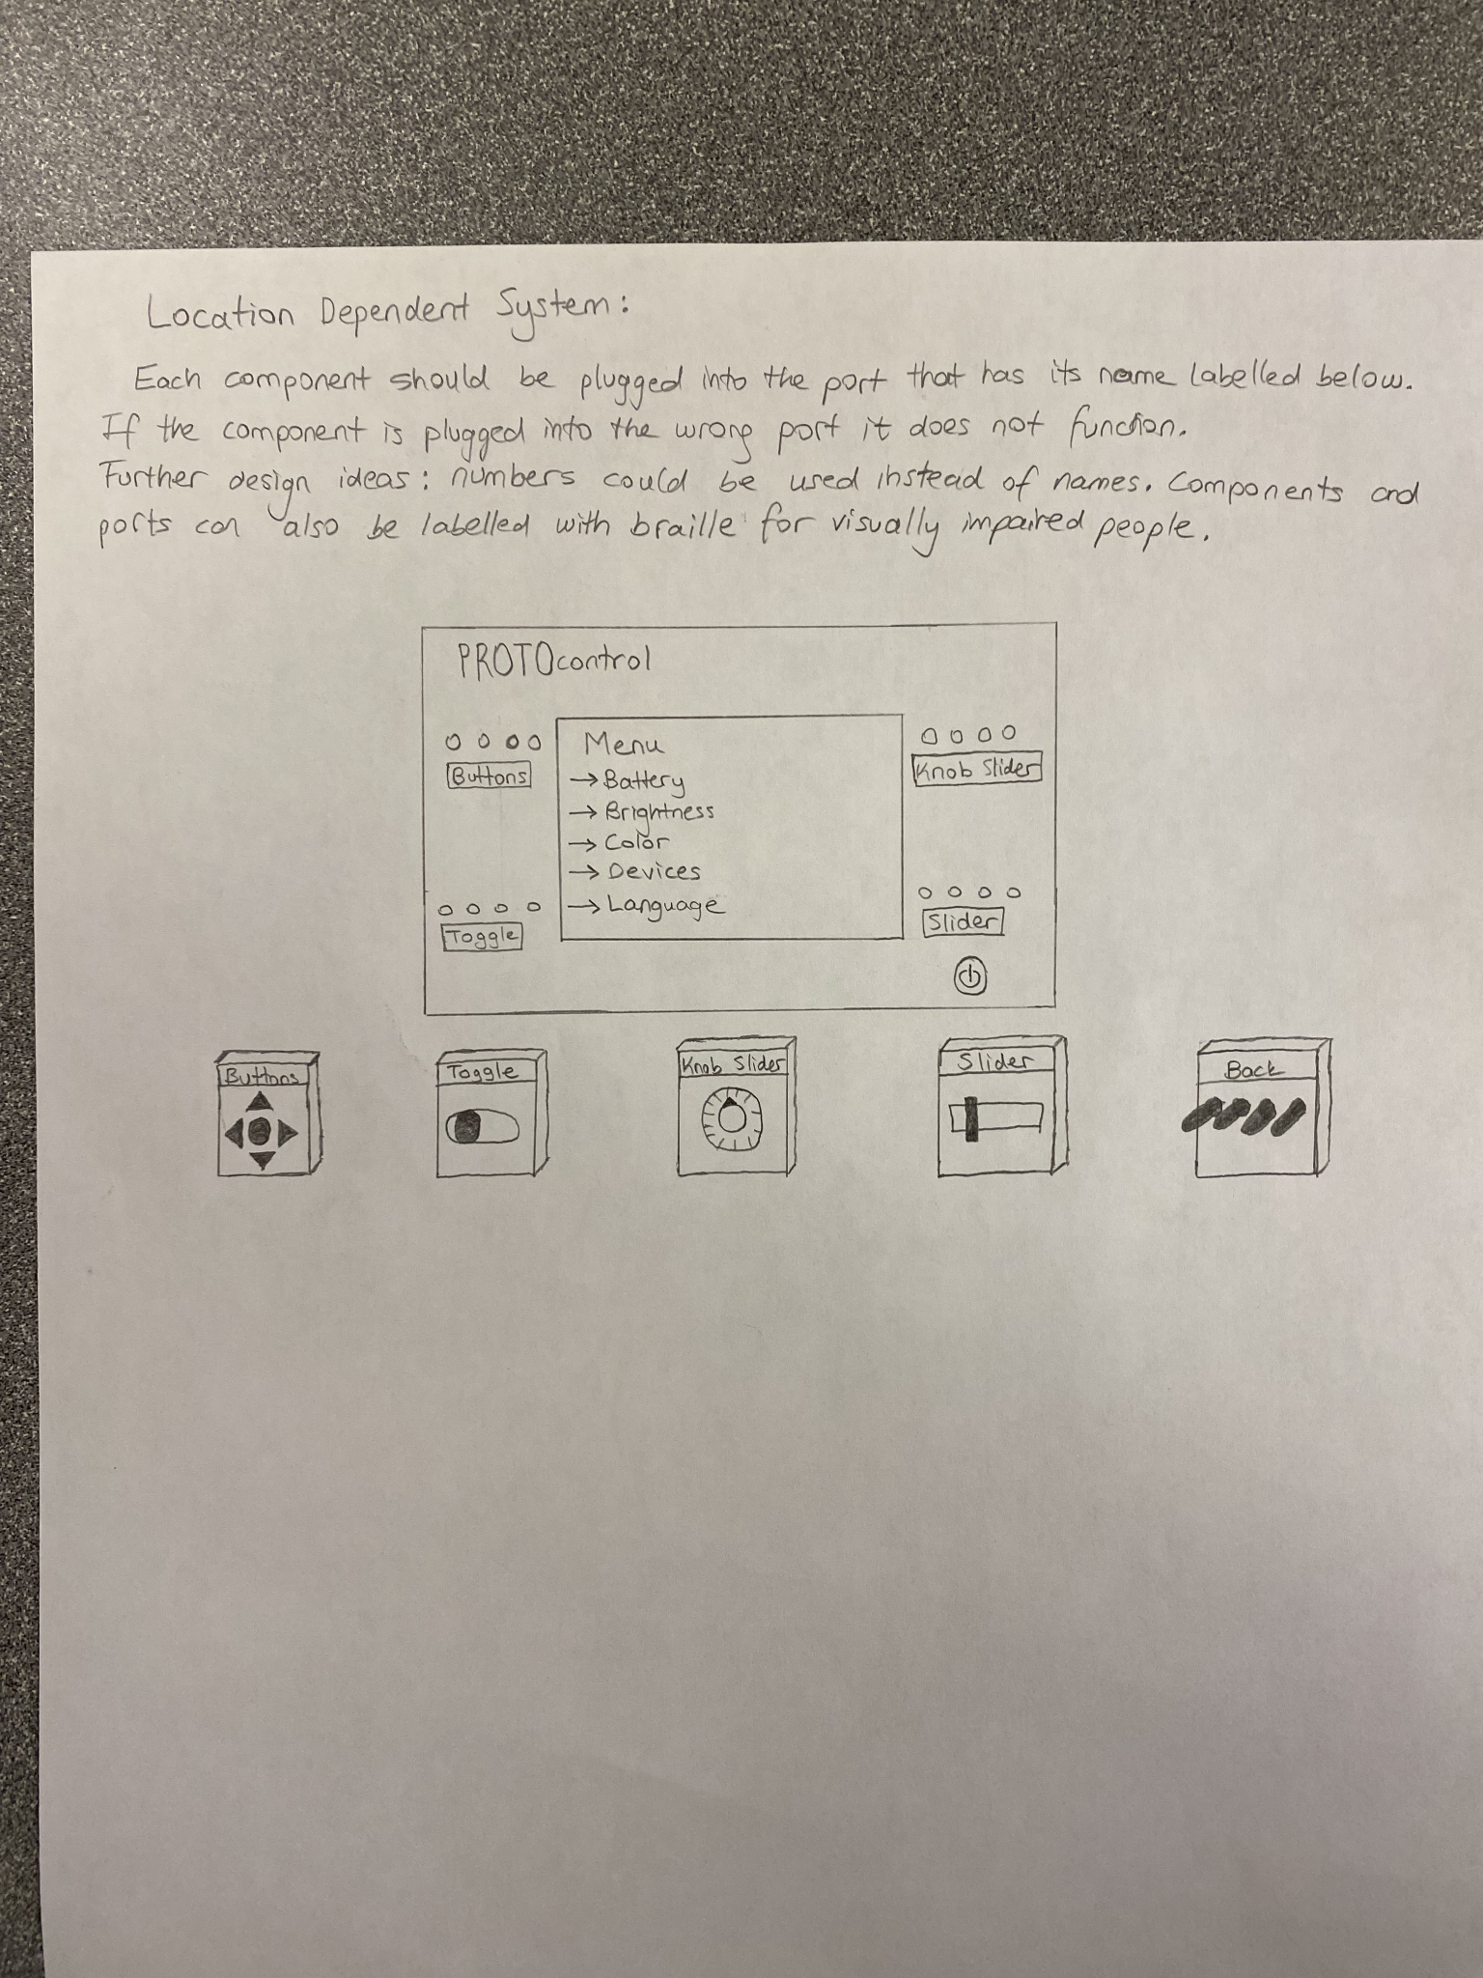

Description: In the location dependent system, the components (buttons and sliders that control the user interface) should be plugged into the main panel at the specified location using I2C. Failure to connect the device to the correct port will result in the component not functioning since the function of the component is dependent on the location of the port.

The measurements of the device is about 5 by 3 inches.

## **2.4 Modular (component dependent)**

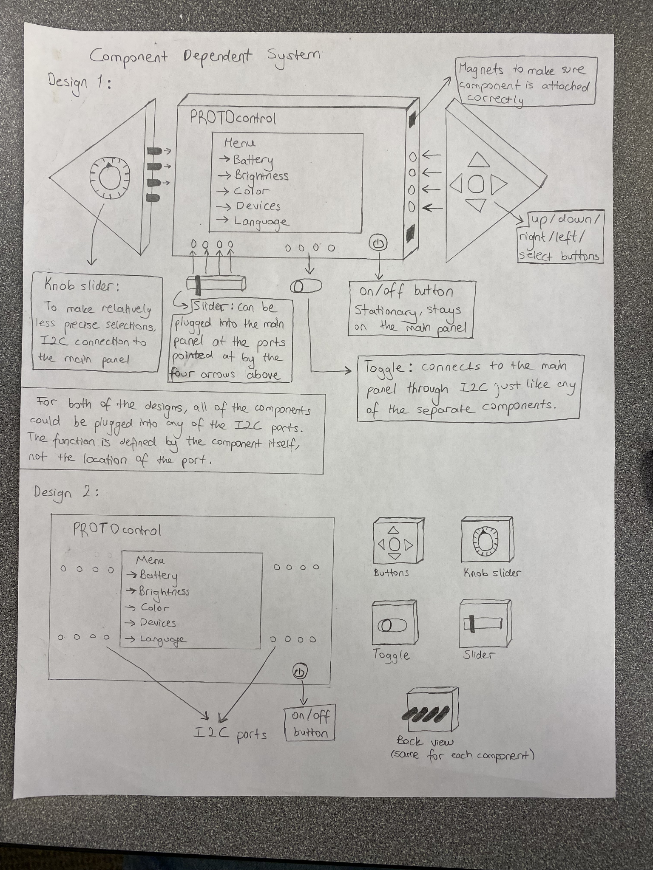

Description: The components (the parts the user is interacting with except for the on/off button) are separate from the main panel of the device which is the LCD displaying the user interface. In this type of system, all of the components can be attached to the main panel at the I2C ports and will be functional regardless of the location it is plugged into on the panel. The functions of the component is defined by the component itself and is not dependent on the port location.

The measurements of the device is about 5 by 3 inches.

## **2.5a Mobile Device as Touch Screen**

## **2.5b Mobile Device as Touch Screen (zoomed in)**

## 

Description**:** This iteration of the design uses a smartphone app as the display as well as the platform to design the display. When the user customizes the display, they can select what pin on their system’s MCU connects to the UI toggle on the mobile app. The hardware IC has a bluetooth module to communicate wirelessly.

## **2.6 Software UI**

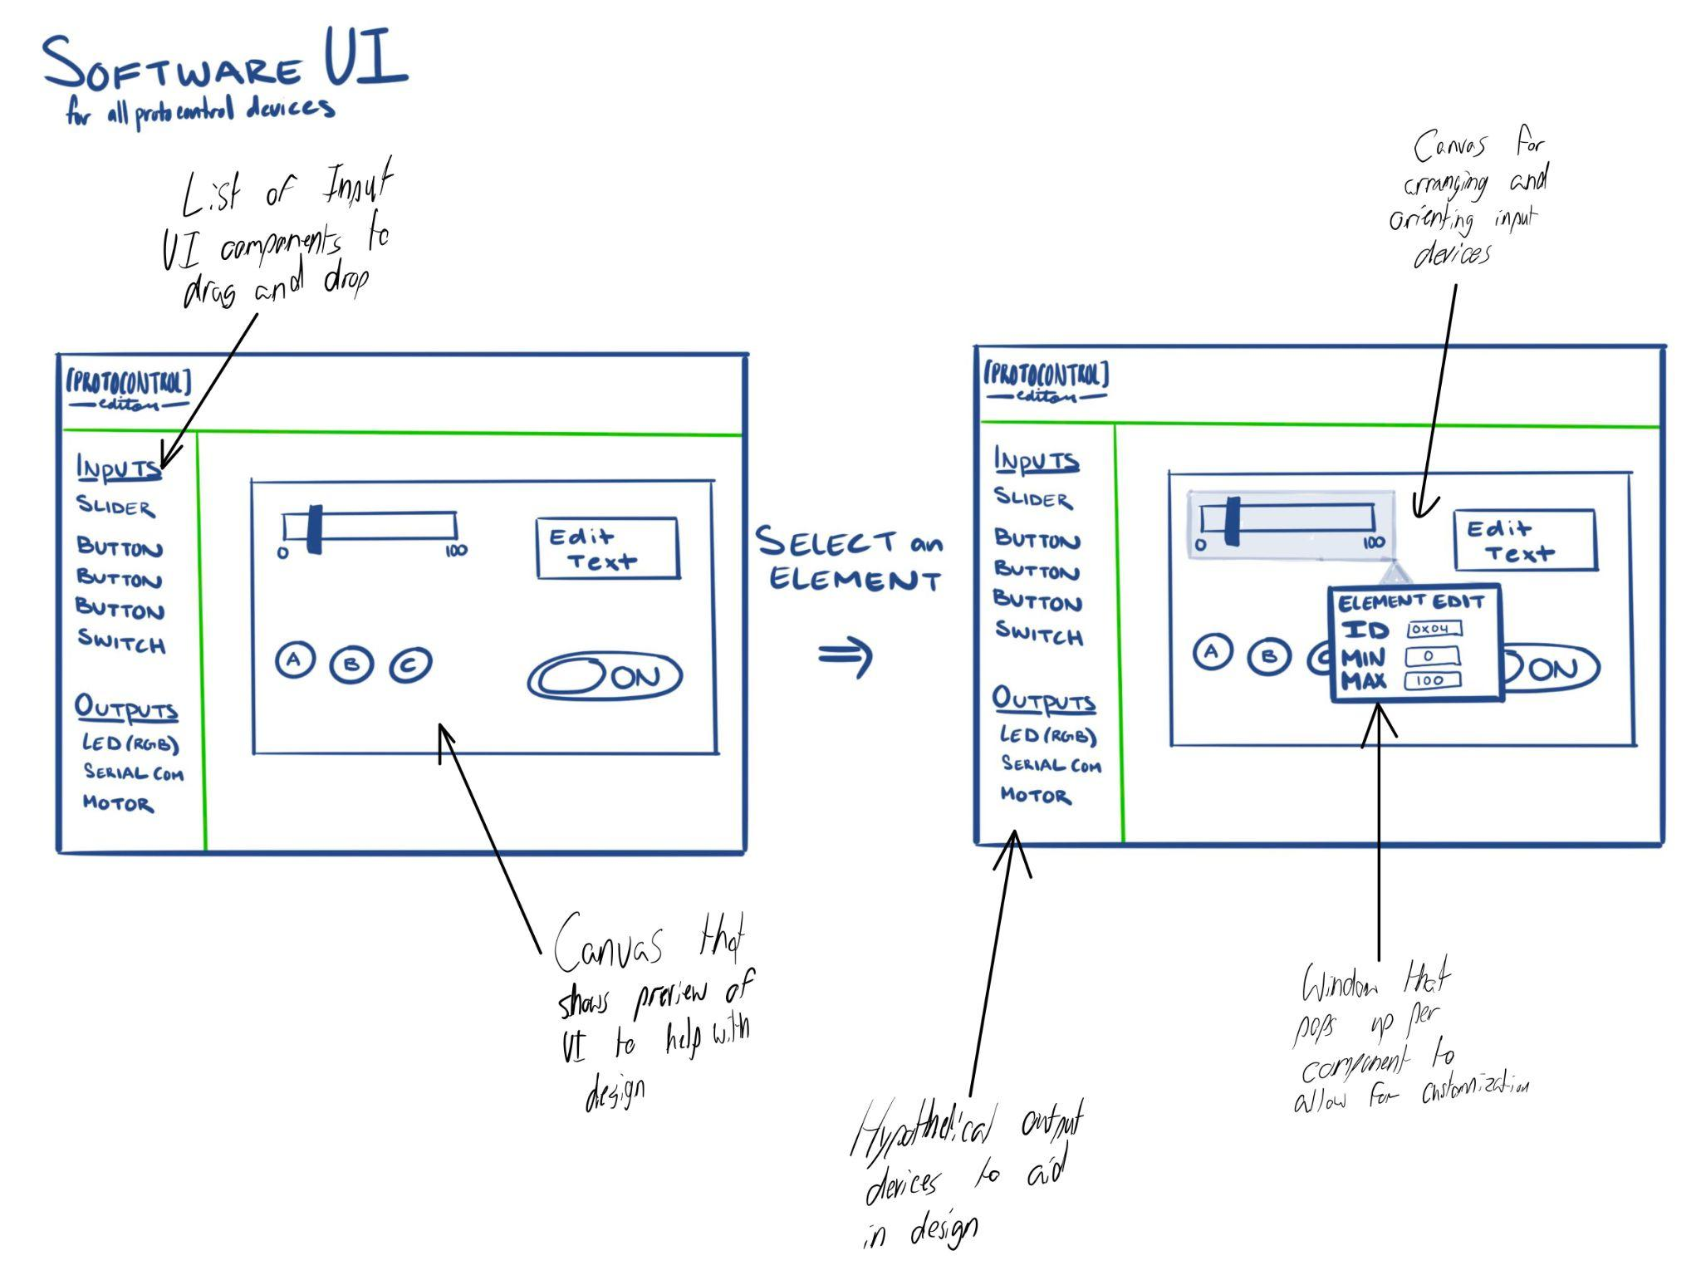

Description: Concept for a web app where the user can design the layout of their display. Users can drag and drop components from a library of inputs and outputs to the canvas. When the user right clicks on a component, a window will pop up and specific features can be edited.

## 

## 

## 

## 

## 

## 

## 

## 

## **Concept differences table and mockup demo preparation:**

|  | 1. ProtoPad | 2. ProtoKit | 3. Modular (location dependant) | 4. Modular (component dependant) | 5. Mobile device and app as system UI | 6. Software UI |
| --- | --- | --- | --- | --- | --- | --- |
| Inputs | Touchscreen | Swappable inputs | From various serial ports | Array of serial ports (i2c) | Website inputs, keyboard, mouse, and uploaded image | Website inputs, keyboard, mouse, and uploaded image |
| Modularity | module | module | Semi modular | Very modular | NA | NA |
| Ease of setup | Very easy, no additional components required | Easy, but need to choose inputs | Challenge of identifying ports | Utilize i2c port array | Lots of software backet dev work | Algorithm work |
| Difficulty of software development | IS REALLY FUN AND KINDA CHALLENGING BUT DO-ABLE | IS LESS CHALLENGING AND MORE MONOTONOUS | TBD | Embedded code to work with all components | Challenging UI work | Algorithm work |
| Making of the concept Mockup | More work initially to set up display | Easier to breadboard out | Design port system, TBD | Relatively straightforward | Non functional frontend doable | Website demo |

Table 1: Concept differences

# **User Operational Flowchart/Process Diagrams**

## **3.1 Software UI/Touchscreen Iteration**

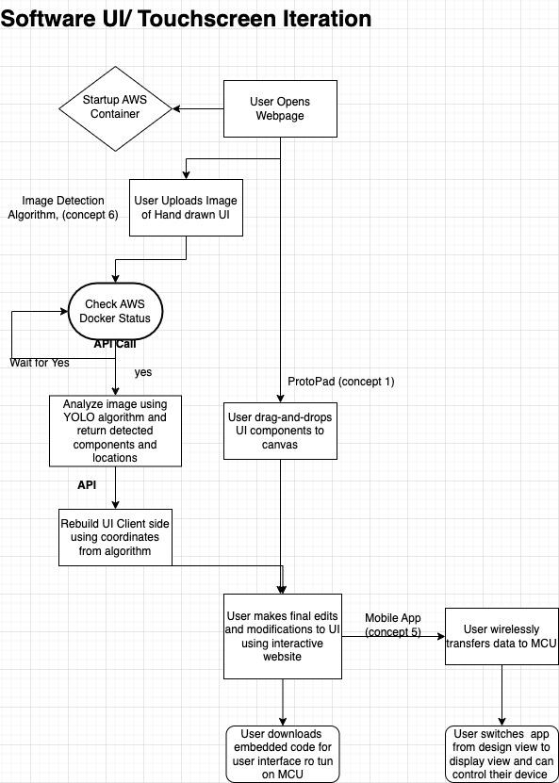

*This diagram shows the process of customizing a Protocontrol panel.*

Flowchart for:

*-ProtoPad (concept 1)*

*-Mobile Device + App (concept 5)*

*-Software UI (concept 6)*

*Left Flow:*

*-includes the Multiple Object Detection Algorithm that accepts a hand-drawn sketch from the user and converts it into a display layout.*

*Right Flow:*

*User opens the webpage and drags and drops UI components on the canvas.*

## **3.2 Physical Components/UI Iteration**

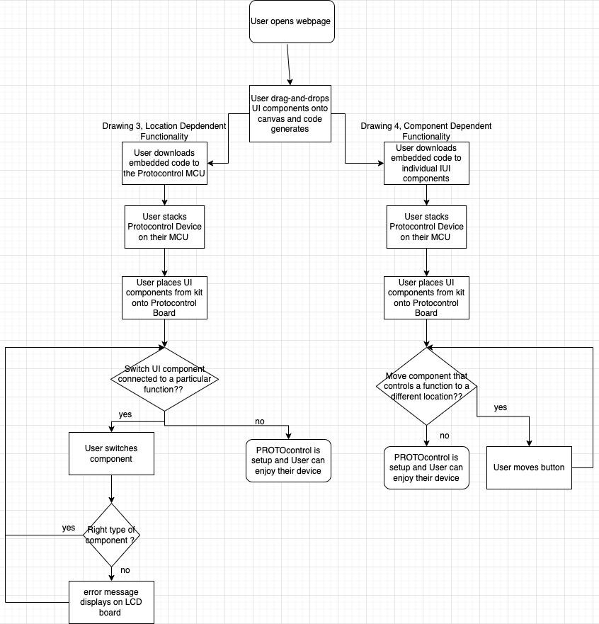

Flowchart for:

* ProtoKit (concept 2)
* Modular Design Location Dependent (concept 3), left flow
* Modular Design Component Dependent (concept 4), right flow

What these components have in common is physical UI components (as opposed to a touch screen) so there is an element of assembly involved in this flow. All these flows assume that the user has received a kit of standard UI components and a board from ProtoControl.

Left Flow:

* Modular Design Location Dependent Functionality
* user can put a variety of UI components (button, switch, toggle, slider) on a pin and that component will continue to control the same output
* Ex. a button that turns on/off an LED can be swapped with a toggle and the toggle will continue to control the LED
* System goes into hold state If the user places a component incorrectly (ie analog component on a digital pin)
* Easily switch out components if another suits the user’s purposes better.

Right Flow:

* Component Dependent Functionality
* Code that controls function is downloaded to the component directly
* Ex. a button that controls the LED can be moved from pin 7 to pin 1 and continue to control the same LED
* Users can create the most optimal layout of components.

## **3.3 ProtoKit Assembled**

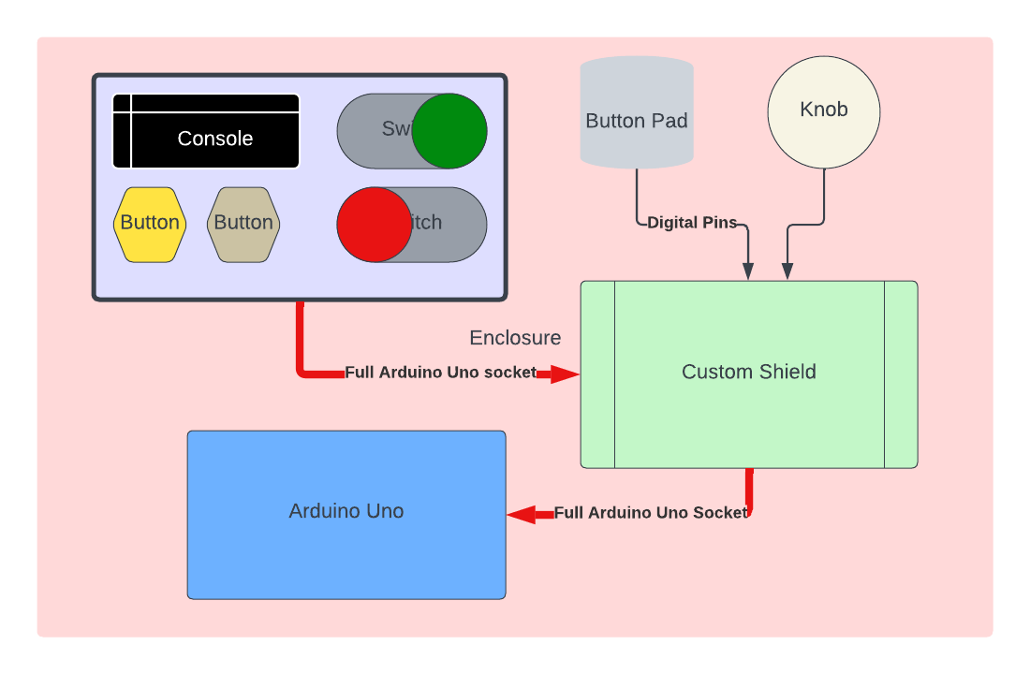

# **System Functional Block Diagram**

## **4.1 Touchscreen (ProtoPad, Mobile App + Smartphone Display, Software UI)**

*Key Differences:*

*Mobile App + Smartphone Display: includes a bluetooth module for wireless data transmission (purple box)*

*Software UI is displayed in 4.1 on the right side in yellow boxes. 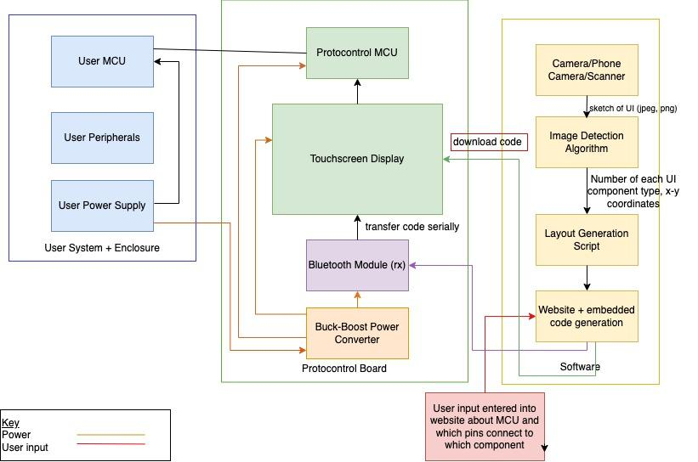*

## **4.2 Physical Component UI (ProtoKit, Component dependent, Location dependent)**

*Key differences:*

*Codependent and Location dependent have different destinations for the embedded code.*

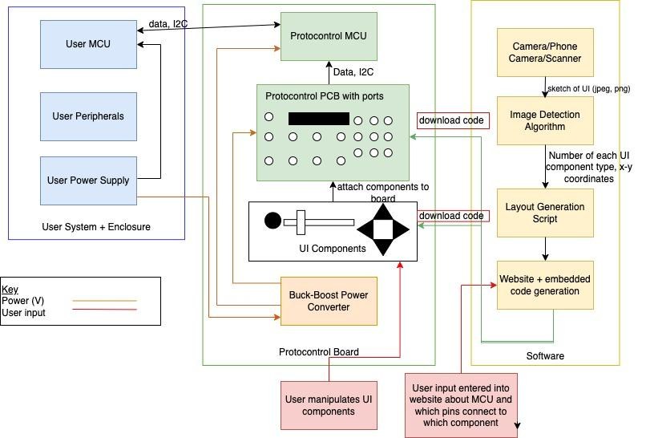

*Description of each block (applicable for 4.1 and 4.2)*

1. *User Microcontroller: Raspberry PI, ESP32, MSP430, Arduino*
2. *User Peripherals: LEDs, servos, sensors, microphone*
3. *User enclosure: will vary in size and shape depending on the customer*
4. *UI components: buttons, sliders, toggles, rotary encoders, LED, LCD display with enclosure*
5. *Protocontrol Microcontroller + PCB + Pin Expander*
6. *Power Converter: step up and step down (DC-DC)*
7. *Image Detection Algorithm: detects hand drawn sketches of UI components*
8. *Camera/Smartphone Camera/scanner: take picture of sketched drawing, user will provide this themselves*
9. *Website + embedded code generation: converts layout + user information into code that can be downloaded to device*
10. *User input: user specifies the type of MCU they are using and what pins control what UI component*
11. *Bluetooth module: Receives data from mobile/web app*

# **Table of Trade-offs**

| Key Requirements/Criteria | ProtoPad | ProtoKit | Location Based | Component-Based | Software |
| --- | --- | --- | --- | --- | --- |
| *Feasibility* | Somewhat feasible  Pro: Touchscreen can be easily interfaced with Arduino Touch shield  Con: Code must be transferred from web app to touchscreen | Feasible  Con: work on enabling various input devices | Con: Need to figure out how to identify locations | Pro: Very feasible using i2c | Con: Somewhat feasible, lots of work |
| *Compatibility* | Pro: Compatible with Arduino form factors and other microcontroller with adapter | Pro: Compatible with any i2c device  Con: | Con: Not as compatible with different layout options, as ports are specific | Pro: Quite compatible, works with every i2c device | Pro: Compatible with any website browser |
| *Ease of use* | Somewhat easy, digital inputs | Pro: Very easy, physical buttons and knobs | Con: Not as easy to use, as ports need to be labeled and remembered | Somewhat easy to use, allows functionality to be tied to components and port location is irrelevant | Pro: Somewhat easy to use  Con: detailed steps are required to instruct thought the process |
| *Ease of making* | Con: need to tune software and touch regions | Pro: Simple process, combine all inputs on network | Design a port identification process | Pro: Simple process, utilize parallel to serial GPIO expander | Con: Lots of testing and UI work |
| *Originality* | Pro: Quite original, with the ability to draw out component locations | Con: Somewhat original, utilized existing serial network Pro: allows for much easier design and customization | Pro: Somewhat original, custom port id process | Con: Somewhat original, uses existing serial network  Pro: allows for modularity | Pro: Very original, Allows for drawn UI |
| *cost* | Medium, capacitive touchscreen alone is $44 | Pro: Low, LCD and Small components under 20 | Pro: Slightly higher than component-based | Pro: Lower cost | Con: High maintenance cost |
| *Overall Evaluation* | Pro: An applicable process for designing a touchscreen user interface. With a huge array of custom input controllers, this process fits almost every application it is suited for | Pro: A simpler, lower cost process for smaller and more focused UI applications. Unbeatable modularity, excellent for user trials | Pro: This process allows for more rapid testing of a single component layout | Pro: This process is incredibly flexible and allows for on the go swapping | Pro: The Software generation is a key breakthrough in removing technical skill from UI design |

# 

# **Design challenges**

* *Universality - Integration with multiple user MCUs*
  + *It will be challenging to integrate the Protocontrol device with the users system and microcontroller (we will be designing with 4 main microcontroller families in mind: ESP, MSP430, R-PI, Arduino). There are several key differences in the major microcontrollers including:*
    - *Power/current ratings*
    - *Operating systems (Raspberry PI uses its own OS)*
    - *Variation in pin locations*
    - *Different processing power*
    - *Presence of wireless connection modules (Arduino has components that can be added on whereas Raspberry Pi can connect to the internet by default)*
* *Automatic code generation (applicable for the touch screen iteration of the project)*
  + *After the user sets up the display and selects which pin on their system connects to each UI component on the display, the appropriate code needs to be generated by the web app so that the user can download it into the MCU provided by Protocontrol.*
* *Modularity - Interfacing with multiple modular components at the same time (applicable for the*

*Hardware Demo iteration of the project)*

* + *System must allow for swappable components (button, switch, toggle) to be attached to main panel pins. For example a user may decide to use a switch instead of a button to control their LED. The system must recognize when UI components are exchanged and detect a change in component function. Outputs must go into a hold state if device is not detected. In the long term, concept drawings 3 and 4 must be combined to create a system that is neither pin location or component dependent. While this gives the user flexibility it means we must account for more variations.*
  + *Components may have different power requirements*
* *Magnets on enclosure may interfere with electronics*
  + *While implementation of a magnetic enclosure is straightforward, resulting issues with electromagnetic interference may be difficult to troubleshoot.*
* *Producing custom ICs*
  + *After the initial design and synthesis phase, designing packaging, and fabricating custom ICs may be a time consuming process.*
  + *In order to create a custom IC, a top level pin diagram is necessary. We must understand what outputs each variation of the system will require of the IC. We must decide on the pins and layout of the pins while many other aspects of the system are still in flux.*

# **First technical milestone Preparation (“Hello World” demos)**

The first technical milestone will be what the team presents during the ECE Hall of Fame Event. The milestones have been decided with this event in mind.

Table 3

| **Identified Technology/Tool** | **Project purpose** | **Specific ways of getting up to speed/help needed** | **“Hello World” demo** |
| --- | --- | --- | --- |
| *Python + Multiple Object Detection Algorithm* | *Project will include a Machine Learning Algorithm for identifying hand drawn i/o components (sliders, toggles, buttons, arrow buttons, textbox, terminal watch window) .* | *Online documentation, Reference previous projects, reach out to experts* | *Train the existing model on hand drawn images created by team members*  *Software Demo*  *Test the trained algorithm with a drawing of UI components on a napkin* |
| *Fusion 360 + ECE MakerSpaces* | *Project will require a 3D printed enclosure (eventually metal) with magnetic snaps (resembling Apple’s mag-safe charger port)*  *Project will benefit from a rendered video of the final product* | *Fusion 360 Tutorials and youtube videos.*  *Mr. Nugyen has documentation for the 3D printing process in EB2.*  *NCSU’s library also offers technology consultations if the problem cannot be resolved earlier.* | *The demo will be 3D printed enclosures (triangle shape shown in earlier drawings) for 3-4 components that connect to a central panel including an LCD display and LED. The enclosure will be made of PLA or ABS plastic.*  *The enclosure will include a place to embed small craft magnets.* |
| *Embedded code for various input components* | *Embedded code is needed for MCU to communicate with any selected component.* | *Adafruit/sparkfun tutorials and example code, online code* | *Hardware Demo*  *The central panel will have and LED and LCD display. There will be 2 ports on the central panel that can accept two main categories of UI component:*  *1) components that can turn on/off the LED*  *2) components that can modify the brightness of the LED.*    *The user will be able to replace a button with a toggle and a slider with a rotary encoder. The system will be able to detect when no input is present and also smoothly transition as the user switches out components.* |

# 

# **Long-lead-time or critical items for purchasing**

Table 4: Items to purchase

(table is linked to “Hardware Inventory and spec sheets” in the “Hardware Files” folder; DO NOT edit here)

| **Item:** | **Description:** | **Cost:** | **Quantity:** | **Vendor:** | **Justification:** |
| --- | --- | --- | --- | --- | --- |
| UNO OLED shield | 2.8" TFT Touch Shield for Arduino with Capacitive Touch | $44.00 | 1.00 | Adafruit | UI component necessary for 1st Demo (Hardware section). I2C protocol compliant. We are planning on creating an enclosure for each component and connecting it to the main panel with an LCD display. |
| I2C Slider | Adafruit NeoSlider I2C QT Slide Potentiometer with 4 NeoPixels - STEMMA QT / Qwiic | $9.95 | 1.00 | Adafruit (5295) | UI component necessary for 1st Demo (Hardware section). I2C protocol compliant. We are planning on creating an enclosure for each component and connecting it to the main panel with an LCD display. |
| I2C Joystick | SparkFun Qwiic Joystick | $11.50 | 1.00 | Sparkfun (com-15168) | UI component necessary for 1st Demo (Hardware section). I2C protocol compliant. We are planning on creating an enclosure for each component and connecting it to the main panel with an LCD display. |
| I2C Button Pad | SparkFun Qwiic Keypad - 12 Button | $11.50 | 1.00 | Sparkfun (com-15290) | UI component necessary for 1st Demo (Hardware section). I2C protocol compliant. We are planning on creating an enclosure for each component and connecting it to the main panel with an LCD display. |
| I2C Rotary Encoder | SparkFun Qwiic Twist - RGB Rotary Encoder Breakout | $24.95 | 1.00 | Sparkfun (dev-15083) | UI component necessary for 1st Demo (Hardware section). I2C protocol compliant. We are planning on creating an enclosure for each component and connecting it to the main panel with an LCD display. |